**Interview from an Animal Shelter**

A journalist went into an animal shelter to interview the dogs there. He first talked to a worker in there.   
Journalist: can people adopt these dogs?  
Animal shelter worker: Yes, people can adopt some of the dogs. But you can’t adopt the dogs that are ill. We have to kill them.   
Journalist: can I have a look at the dogs now,  
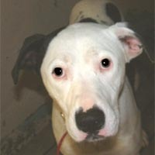Animal shelter worker: yes you can.   
  
**The Pitbull, Pete**  
Journalist: Am I welcome to come in?   
Pete: Yes, you are welcome.   
Journalist: What is your name?   
Pete: My name is Pete  
Journalist: Why are you here?   
Pete: I am here because my master doesn’t have space in his house. And people say I am dangerous.  
Journalist: Are you dangerous?   
Pete: No, I am not dangerous. People think I am because they think all pitbulls are dangerous, but pitbulls aren’t dangerous, only some of us are.   
Journalist: Do you feel okay here?   
Pete: No, I don’t. I worry about my boss. Will he be okay without me?   
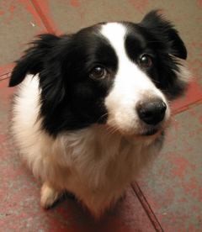Journalist: I hope he will be.

**The Border Collie, Popper**Journalist: May I come in?   
Popper: Yes you may. Journalist: hello dog, is it okay if I talk to you?   
Popper: Yes, what would you like to talk about?   
Journalist: what kind of dog are you?   
Popper: I am a Border Collie, I am good with sheep.   
Journalist: have you been in this place for long?   
Popper: I have been here for a long time.   
Journalist: Do you know why you are here?   
Popper: No I don’t know.   
Journalist: What do you normally do?   
Popper: I don’t do anything in here. But normally I keep the sheep together. I once bit a sheep in his leg. Then I had to come here. Can you please tell my master that I want to come home?

**The Rottweiler, Spartan**Spartan: is there someone there?   
Journalist: yes, I am here. Can I talk to you?  
[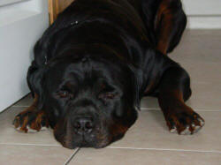](http://www.animalliberationfront.com/Practical/Pets/Stories/rottweiler1.jpg)Spartan: Yes you can. Don’t be afraid, I don’t bite.   
*** the dog coughs badly***  
Journalist: Are you okay?  
Spartan: Yes, I’m okay. Many dogs here have a cough. It isn’t nice.   
Journalist: Why are you here?   
Spartan: I wanted to be a nice dog.  
Journalist: are you a nice dog?   
Spartan: Yes, I am a nice dog. My master isn’t a nice master. He wanted me to bite people. I wanted to play with them.   
Journalist: Can you tell me what happened then?   
Spartan: One day I wanted to play with people but my boss wasn’t happy. He beat me with a stick. Then he brought me here.

*Source:* <http://www.animalliberationfront.com/Practical/Pets/Stories/InterviewAnimalShelter.htm>(adapted)